Basic commands

ls -> list directories
cd <file name> -> change directory to another file
npx create-next-app@latest -> creates a Next.js application
npm run dev -> starts the application
npm -> stands for „node package manager“
npm install @mui/material @emotion/react @emotion/styled -> installs Material UI

In order to use tags from Material UI, we first have to import them:
i.e. import Typography from ‚@mui/material/Typography‘;

Material UI <Typography> tag:
<Typography variant=“h1“ gutterBottom>
Text goes here
</Typograhy>

Adds text, similar to a paragraph in HTML. We can also set variants (h1, h2, h3, etc.)

Material UI <Container> tag:
<Container>
Content goes here
</Container>

Container adds responsivness, it is partially related to a div but not the same

To rename the website title, we use metadata:
export const metadata = { title: `Example | Website Name`}

npm run build -> builds the project in production mode (way safer and faster than developer mode, meant for releasing the project)
npm run start -> runs the project in production mode

Basic structure of the website:
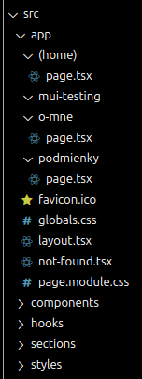

page.tsx -> contains the actual content of the page
layout.tsx -> contains the layout of the page
not-found.tsx -> custom 404 error page

Every page of the website is located in its own dedicated folder with page.tsx and layout.tsx

Routing is automatic, the only thing we have to do is create the folders for each one of the consecutive pages along with page.tsx in order for it to work. We access the individual pages with a URL paramater, i.e. localhost:3000/about-me

The (home) folder serves as the root or home of the website, it appears when the URL parameter of the website is empty (localhost:3000/)

Readability is also very important and we should try to minimize the amount of lines to make the code look as clean and tidy as possible, along with providing the directory inside a comment on top of the code.

Setting up git
git init -> creates the git directory
git branch -m <name> -> renames the initial branch
git config –global user.name <username> -> sets the git username
git config –global user.email <email> -> sets the git email
git remote add origin <repository link> -> links the git to a GitHub account
git remote -v
git add .
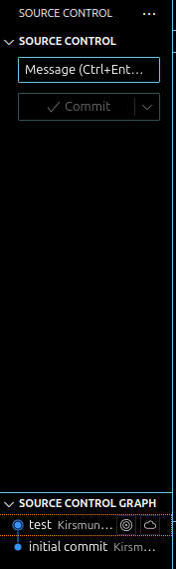

A message is required to identify which branch we are dealing with.

We can see all our previous commits down below or on GitHub.
Vercel je produkčný server, ktorý nám umožní projekt hostovať na internete. Stačí si vybrať GitHub repository a stlačiť Deploy. Potom už si len zobrazíme príslušnú adresu na akomkoľvek zariadení, napr. https://zoskagram.vercel.app/.

